# DBS301 Lab 4 – Muhammad Ahmed – ID: 126330166 Sec: D

**- Prof. Nebojsa Conkic**

1.select (max(salary) – min(salary)) as “Big Difference”

from employees;

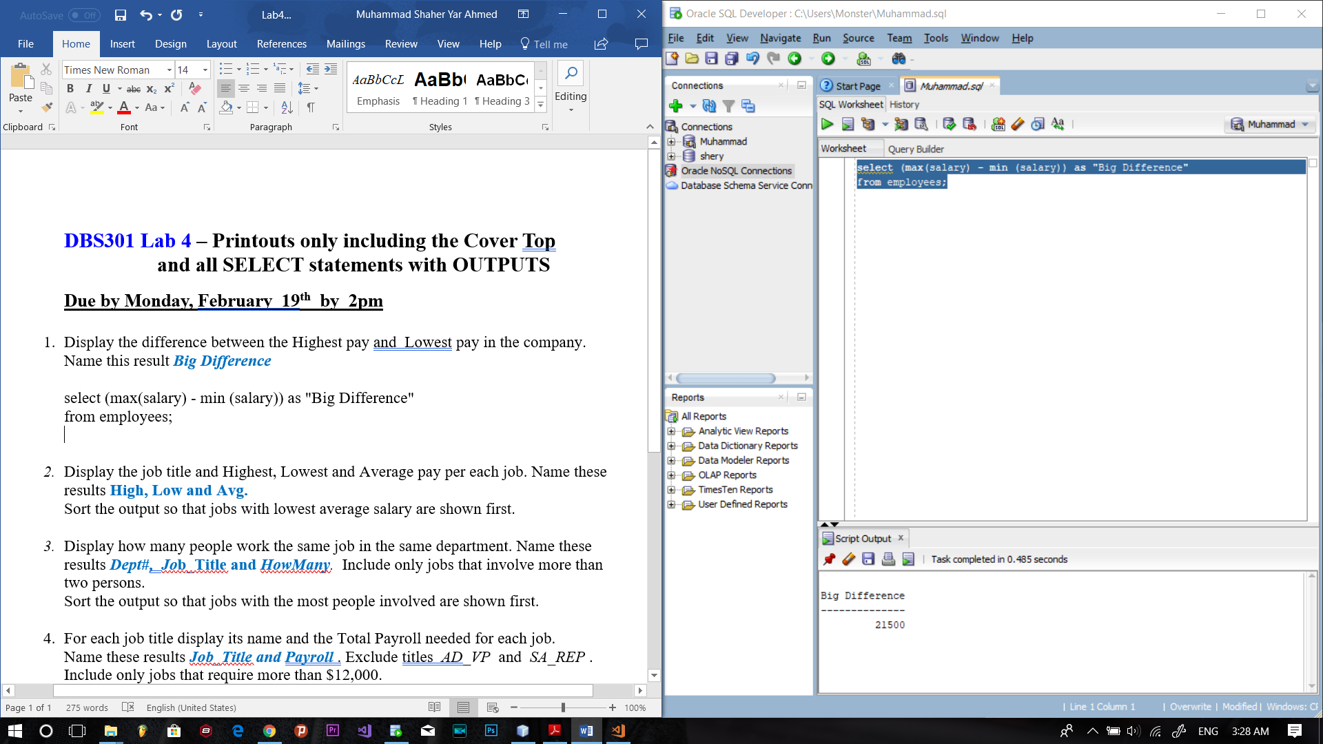

2.

select job_id, max(salary) "High", min(salary) "Low", avg(salary) "Avg"

from employees

group by job_id

order by avg(salary) desc;

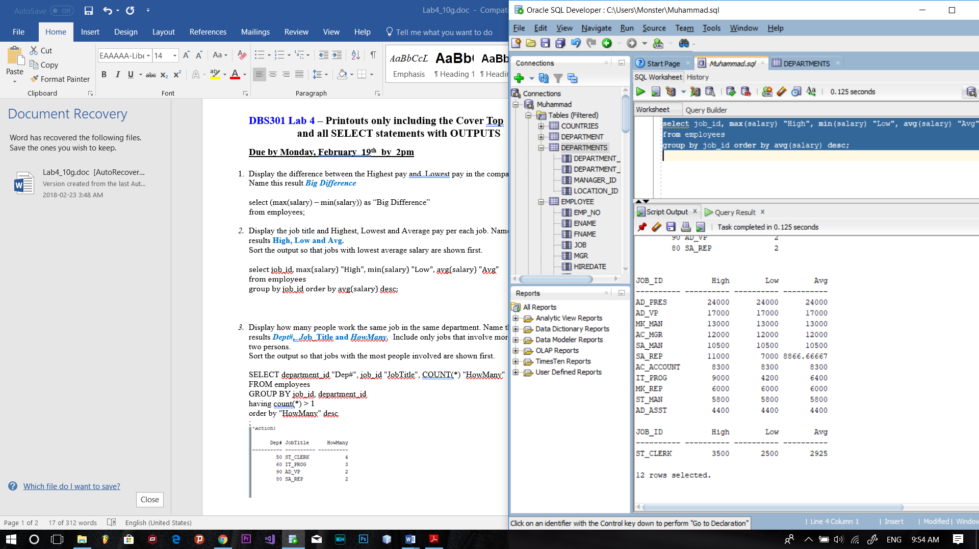

3.

SELECT department_id "Dep#", job_id "JobTitle", COUNT(*) "HowMany"

FROM employees

GROUP BY job_id, department_id

having count(*) > 1

order by "HowMany" desc

;

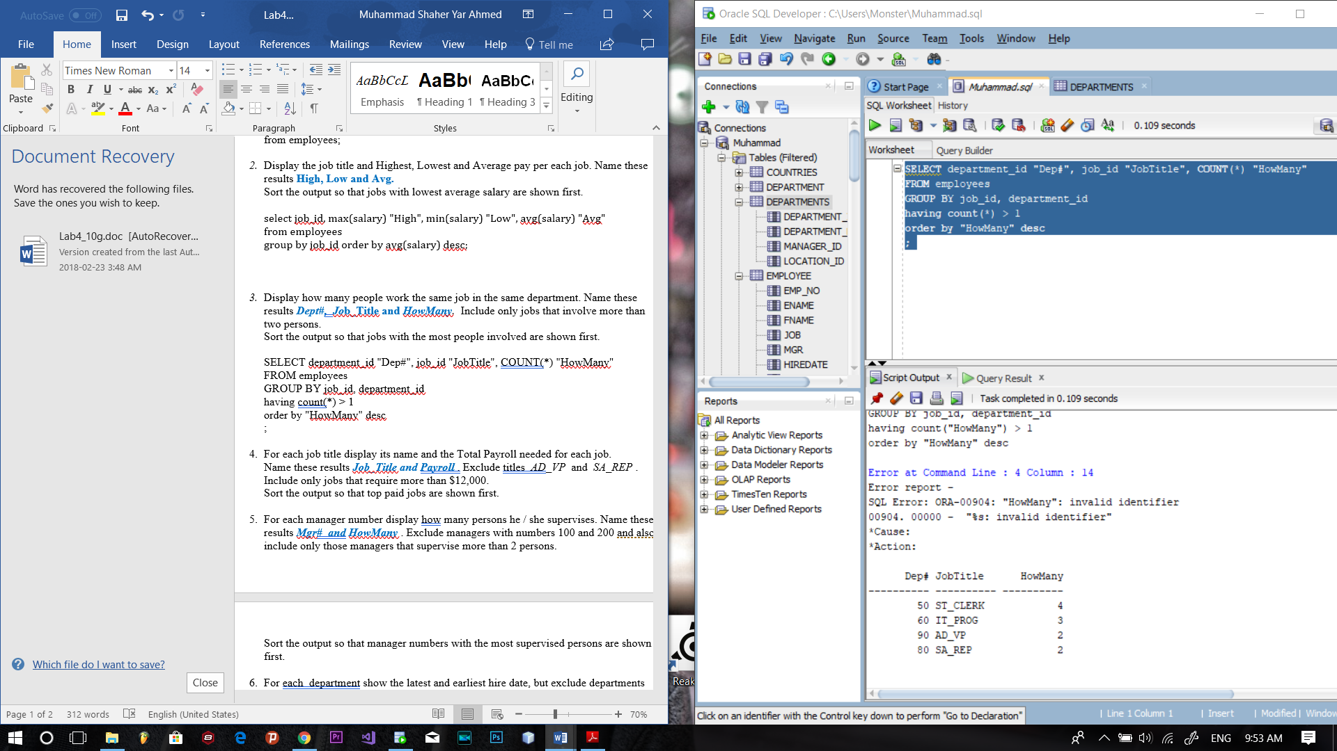

4.

select job_id, sum(salary) "Total Payroll"

from employees

group by job_id

having job_id != 'AD_VP' and job_id != 'SA_REP' and sum(salary) >= 12000

order by sum(salary) desc;

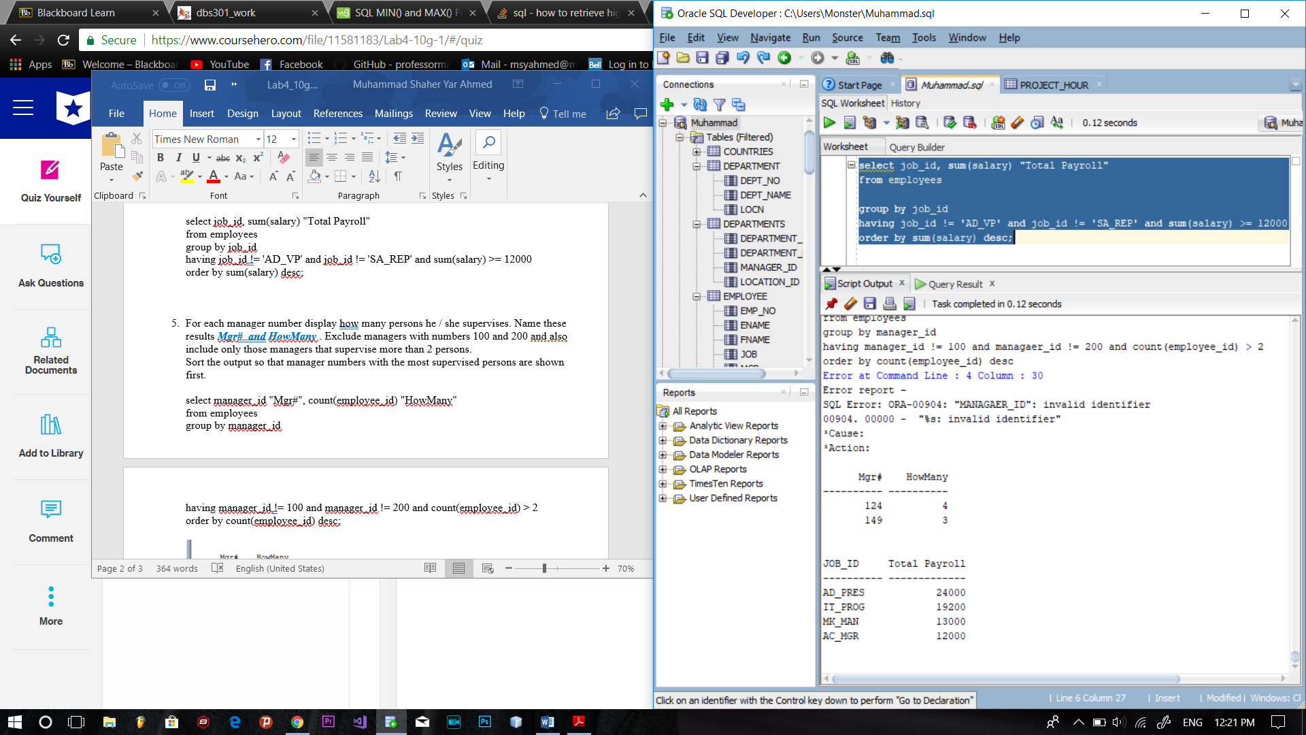

5.

select manager_id "Mgr#", count(employee_id) "HowMany"

from employees

group by manager_id

having manager_id != 100 and manager_id != 200 and count(employee_id) > 2

order by count(employee_id) desc;

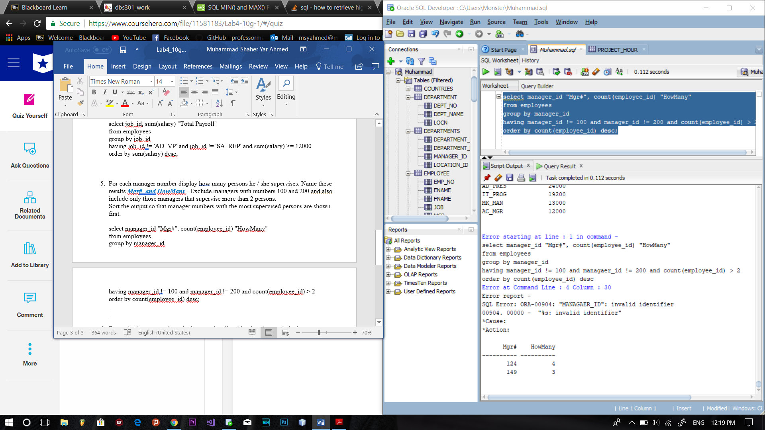

6.

select department_id, min(hire_date) Earliest, max(hire_date) Latest

from employees

group by department_id

having (min(hire_date) < '00-01-01') and (min(hire_date) >= '90-01-01') and department_id > 59

ORDER BY MAX(HIRE_DATE) desc;

